## **HCI 598 M1 - Your Idea Ashley Otero**

* **Working Title:** DOE RTC Data
* **Users:** Photovoltaic manufacturing and solar installation companies, PV/solar researchers, and the general public.
* **Problem:** The non-proprietary performance data recorded by the Department of Energy’s Regional Test Centers (RTC) should be publically available. Currently, there is no way to access this data, and the RTC sites are continually gathering a backlog with no path forward to disseminate. The accessibility of this data is critical in demonstrating the value of the RTC program for the PV and greater solar industry within the United States.
* **Strategy for addressing the problem:** I propose to create a web-based system that ingests data from all 5 RTC sites to a centralized database that will allow for public downloads and visualizations of data.
* **My relationship to this problem:** I currently work for Sandia National Laboratories Energy, Climate, & Homeland Security division. As a part of my work, I am the external technical communications specialist for the RTCs. The RTC program provides the United States photovoltaic (PV) industry with system field performance and degradation monitoring via access to field sites to test PV products in a variety of climates. I have a software design and development background, and I have identified the need for this system to be built and received, knowing that I have the necessary skill set to implement the solution. I have unlimited access to PV/solar researchers, and industry PV partners.

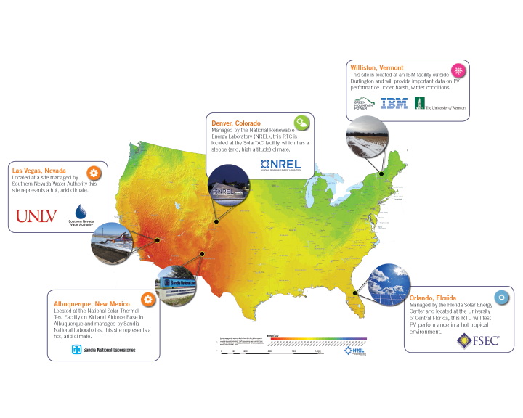

*RTC Test Sites Map*